Supplementary Materials

Supplemental Figures:

- Table S1: Summary of studies measuring local adaptation to host plants in eastern and western monarchs
- Table S2: Summary of studies comparing wing length of eastern and western monarchs
- Figure S1: Map of occurrence records for immature monarchs (eggs, larvae, pupae) from iNaturalist database.
- Figure S2: Comparison of July-August daytime high temperatures for immature monarchs in eastern and western breeding locations.
- Figure S3: Comparison of BIO10 (Mean Temperature of Warmest Quarter) for immature monarchs in eastern and western breeding locations.
- Figure S4: Correlation between eastern and western overwintering numbers using a one-year time lag.
- Figure S5: Correlation between eastern and western overwintering numbers using a one-year time lag but after omitting two pairs of overwintering seasons.

Appendix 1: Summary of methods used for comparisons thermal environments of eastern and western North America.

Appendix 2: Summary of methods used for comparisons thermal environments of eastern and western North America.

Study | Eastern hosts used | Western hosts used | Experimental details | Local adaptation measure | Strength of local adaptation
Ladner and Altizer (2005) | A. syriaca  A. incarnata | A. speciosa  A. fascicularis | Cut stems used for larval performance assays | Oviposition preference | Host*population  p = 0.39
 |  |  |  | Larval survival | Host*population  p = 0.89
 |  |  |  | Larval growth rate | Host*population  p = 0.84
Freedman et al. (2020a) | A. syriaca  A. incarnata | A. speciosa  A. fascicularis | Live intact host plants used for assays | Larval survival | Sympatric/allopatric  p = 0.48
 |  |  |  | Larval growth rate | Sympatric/allopatric  p = 0.15
 |  |  |  | Time to eclosion | Sympatric/allopatric  p = 0.73
 |  |  |  | Eclosion mass | Sympatric/allopatric  p = 0.95
Table S1: Summary of common garden experiments that have tested for local adaptation to host plant assemblages in eastern and western monarchs. The column for strength of local adaptation reports the metric used for assessing local adaptation and corresponding p-value.

Study | Wild caught? | Sample | N | Length (mm) | Area (mm²) | %Diff  Length | %Diff  Area | Notes
Beall and Williams (1945) | Wild | Eastern | 1274 | 51.82 | NA | 3.02% | NA
Beall and Williams (1945) | Wild | Western | 296 | 50.30 | NA | 3.02% | NA
Altizer and Davis (2010) | Wild | Eastern | 302 | 51.33 | 872.3 | 2.19% | 3.24% | 37 eastern and 29 western maternal families
Altizer and Davis (2010) | Wild | Western | 259 | 50.23 | 844.9 | 2.19% | 3.24% | 37 eastern and 29 western maternal families
Altizer and Davis (2010) | Common garden | Eastern | 584 | 50.92 | 869.3 | 0.43% | 1.42% | 37 eastern and 29 western maternal families
Altizer and Davis (2010) | Common garden | Western | 260 | 50.70 | 863.5 | 0.43% | 1.42% | 37 eastern and 29 western maternal families
Li et al. (2016) | Wild | Eastern | 60 | 51.51 | 852.2 | 0.88% | 1.42%
Li et al. (2016) | Wild | Western | 59 | 51.06 | 840.3 | 0.88% | 1.42%
Freedman and Dingle (2018) | Wild | Eastern | 844 | 50.91 | 849.5 | 1.58% | 2.32% | Includes samples from Li et al. (2016) and Yang et al. (2016)
Freedman and Dingle (2018) | Wild | Western | 809 | 50.12 | 830.2 | 1.58% | 2.32%
Talla et al. (2020) | Wild | Eastern | 32 | 52.10 | 883.0 | 3.9% | 8.21%
Talla et al. (2020) | Wild | Western | 31 | 50.16 | 816.0 | 3.9% | 8.21%
Freedman et al. (2020b) | Common garden | Eastern | 171 | 51.12 | 898.1 | 0.63% | 1.28% | 12 eastern and 16 western maternal families
Freedman et al. (2020b) | Common garden | Western | 187 | 50.80 | 886.7 | 0.63% | 1.28% | 12 eastern and 16 western maternal families
Table S2—Summary of studies that have directly compared wing morphological data from eastern and western monarchs. The columns for length and area reflect overall averages based on data in papers and do not separate males and females. The %diff columns reflect the degree to which eastern monarchs are larger than western monarchs.

Appendix 1

To generate distribution maps and climate data for summer-breeding monarchs, we downloaded monarch occurrence records from the Global Biodiversity Information Facility (GBIF) (dataset ID: doi.org/10.15468/dl.jx7wck). We then filtered these data to include only records from the United States and Canada during July and August, which coincides with the peak of the monarch’s summer breeding period. Summertime records of monarchs in locations known to support year-round breeding populations (e.g. South Florida, coastal Georgia and the Carolinas, areas along the Gulf Coast, and southern California) were excluded from analyses. The map in Figure 1A was created using the ggmap package (Kahle and Wickham 2013)
We separated monarchs into eastern versus western North America based on their location relative to the continental divide. This left us with 19,286 eastern and 1,266 western records from July and August. We then used the coordinates listed in the GBIF database to pull data on 30 year July-August temperatures (1988-2018) from the PRISM database (PRISM Climate Group) using the prism package v0.0.6 (Hart and Bell 2015), as well as Bioclim data from the WorldClim v2.1 database (Fick and Hijmans 2017) using the raster package v3.1-5 (Hijmans 2020). PRISM data was generated at 4 km resolution, while WorldClim data was generated at 2.5 minute resolution. Because PRISM only includes data from the continental United States, we also downloaded 1981-2010 climate normals for all Canadian provinces with monarch occurrence records (Environment and Climate Change Canada). Canadian monarch occurrences were matched to climate records for the nearest recording station using the distm function in the geosphere package v1.5-10 (Hijmans 2019). For summertime temperature records, we averaged July and August daytime high temperatures and used this value as our index of the thermal environment experienced by adult monarchs (see Figure 2A). For summertime precipitation, we used BIO18 (precipitation during the warmest quarter) for each monarch occurrence record and used this value as our index of summertime precipitation (see Figure 2B).
These metrics are not meant to be fully representative of conditions experienced by monarchs and are instead rough approximations of temperature and precipitation conditions in locations where adult monarchs have been recorded during July-August. Among the caveats in our analysis are that (1) adult monarchs are highly mobile, and so the location where they are observed may not accurately describe the conditions that they experience over their lifetime; (2) occurrence records were not spatially thinned, and so areas with higher human population density (and hence higher observation probabilities) are weighed disproportionately; (3) our climate metrics reflect seasonal or quarterly averages, rather than conditions experienced on the day of collection. Still, in spite of these caveats, we feel that the metrics used and shown in Figure 2 are broadly representative of summertime conditions experienced by eastern and western monarchs.
Immature monarchs are likely more sensitive to thermal stresses because of their relative immobility. Thus, to determine whether the results we obtained using GBIF records (which include all life stages) were biased due to the inclusion of adult records, we separately analyzed data from only eggs, larvae, and pupae. We used monarch observations through iNaturalist and the associated R package iNatTools (Hanly 2019). Out of the approximately 121,000 currently available research grade observations available through iNaturalist, about 32,000 are annotated to indicate a life stage of larva, pupa, or egg (link here has URL specifying these search terms). This includes approximately 13,500 observations of larvae, pupae, and eggs from July and August in areas of the United States and Canada where migrants breed in the summer (Figure S1). This analysis yields a similar result to that presented based on records for all life stages: immature monarchs in western North America experience higher daytime high temperatures during July and August (median daytime high = 28.91ºC) compared to immature eastern monarchs (median daytime high = 26.80ºC) (Figure S2).
We do note that the analyses presented only focus on daytime high temperatures during the peak of summer breeding. The rationale behind this decision was that daily high temperatures are more likely to reflect the thermal tolerances and niche breadth of monarchs; this reasoning has been used to explain the scarcity of monarchs from the southern United States during the hottest parts of the year. When an alternate metric is used from the BioClim database (BIO10 – Temperature of the Warmest Quarter), eastern monarchs (both adults and immature stages) experience slightly higher summertime temperatures. However, this metric takes into account nighttime low temperatures, which tend to much higher for humid eastern locations. Thus, western monarchs (both adults and larvae) on average experience greater temperature extremes, including warmer high temperatures and greater diurnal fluctuations (Figure S3), than eastern monarchs.

References

- Environment and Climate Change Canada: Canadian Climate Normals 1981-2010. https://climate.weather.gc.ca/climate_normals/. Accessed July 2019.
- Fick, S.E. & Hijmans, R.J. (2017). WorldClim 2: new 1‐km spatial resolution climate surfaces for global land areas. Int. J. Climatol., 37, 4302–4315.
- Global Biodiversity Information Facility (GBIF). Dataset ID: doi.org/10.15468/dl.jx7wck. Created July 1, 2019.
- Hijmans, R.J. (2019). geosphere: Spherical Trigonometry. R package version 1.5-10.
https://CRAN.R-project.org/package=geosphere
- Hijmans, R.J. (2020). raster: Geographic Data Analysis and Modeling. R package version
3.1-5. https://CRAN.R-project.org/package=raster
- PRISM Climate Group: 30-Year Normals, Mean Temperature. Oregon State University, http://prism.oregonstate.edu, Accessed July 2019.
Figure S1 – Map of occurrence records for immature monarchs from eastern (n = 12,905) and western (n = 519) North American locations. Data do not include records from locations where monarchs are known to breed year-round. Occurrence records sourced from iNaturalist using the iNatTools package (Hanly 2019).
Figure S2 – Consistent with results from larger GBIF occurrence database that included adult records, immature monarchs from western North America experience, on average, warmer daytime high temperatures during the peak of the summer breeding season. Dashed vertical lines correspond to median values.

Figure S3 – In contrast to daily high temperatures, eastern monarchs experience slightly higher overall summertime temperatures than western monarchs, owing to greater nighttime low temperatures in eastern locations.
Appendix 2

To compare overwintering eastern and western populations, we used data from WWF Mexico (eastern) and Schultz et al. (2017) and the Xerces Society Thanksgiving monarch count (western). Eastern overwintering numbers are displayed as hectares occupied, with each hectare corresponding to approximately 21-28 million adults monarchs (Thogmartin et al. 2017a). We used simple linear regression to test for a correlation between eastern and western overwintering numbers within a given year and found only a weak positive correlation (R² = 0.02, p = 0.41), shown in Figure 1B.
Based on an earlier analysis suggesting that western overwintering numbers may be correlated with the previous year’s eastern population (Vandenbosch 2007), we conducted a similar analysis, shown below in Figure S1. We also found that western overwintering numbers are significantly positively correlated with eastern overwintering numbers in the preceding year (R² = 0.50, p < 0.001), consistent with Vandenbosch (2007). However, we note that this analysis is driven almost entirely by two years of high abundance in western North America (1996 and 1997) that also correspond to years with high uncertainty in overwintering estimates (Schultz et al. 2017). When these two years are omitted from analysis, the correlation is no longer significant (Figure S2). The positive correlation between eastern and western overwintering numbers (both within years and using a one-year time lag) may also reflect that both populations have declined over their monitoring periods, though likely for different underlying reasons (Pleasants and Oberhauser 2013, Thogmartin et al. 2017b, Agrawal and Inamine 2018, Crone et al. 2019).

References

- Agrawal, A.A. & Inamine, H. (2018). Mechanisms behind the monarch’s decline. Science, 360, 1294–1296.
- Crone, E.E., Pelton, E.M., Brown, L.M., Thomas, C.C. & Schultz, C.B. (2019). Why are monarch butterflies declining in the West? Understanding the importance of multiple correlated drivers. Ecol. Appl., 29, e01975.
- Pleasants, J.M. & Oberhauser, K.S. (2013). Milkweed loss in agricultural fields because of herbicide use: effect on the monarch butterfly population. Insect Conserv. Divers., 6, 135–144.
- Schultz, C.B., Brown, L.M., Pelton, E. & Crone, E.E. (2017). Citizen science monitoring demonstrates dramatic declines of monarch butterflies in western North America. Biol. Conserv., 214, 343–346.
- Thogmartin, W.E., Diffendorfer, J.E., López-Hoffman, L., Oberhauser, K., Pleasants, J., Semmens, B.X., et al. (2017a). Density estimates of monarch butterflies overwintering in central Mexico. PeerJ, 5, e3221.
- Thogmartin, W.E., Wiederholt, R., Oberhauser, K., Drum, R.G., Diffendorfer, J.E., Altizer, S., et al. (2017). Monarch butterfly population decline in North America: identifying the threatening processes. R Soc Open Sci, 4, 170760.
- Vandenbosch, R. (2007). What do monarch population time series tell us about eastern and western population mixing? J. Lep. Soc., 61, 28-31.

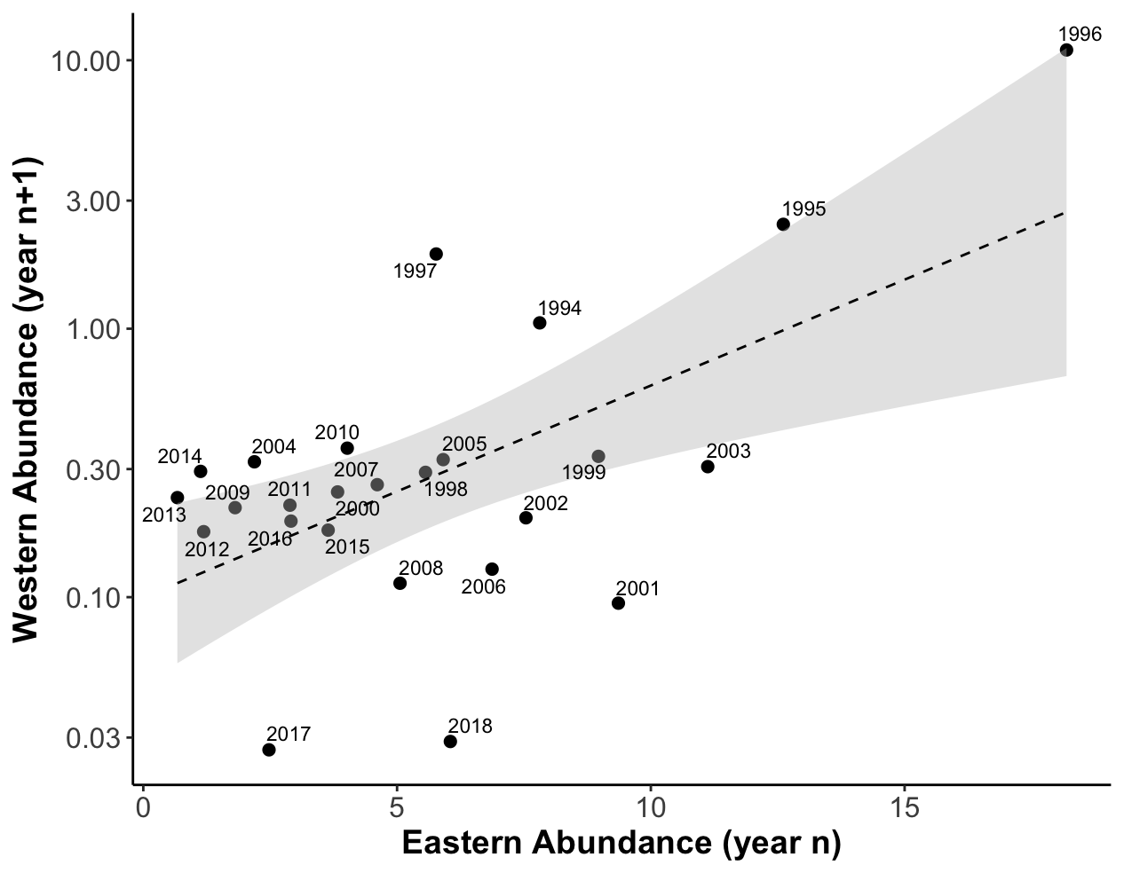
Figure S4 – When overwintering populations are plotted using a one-year time lag, eastern and western North American monarchs are strongly positively correlated (R² = 0.50, p < 0.001). In the plot above, a given point corresponds to eastern overwintering abundance in a particular year, and the western overwintering abundance in the following year (e.g. the point labeled 2003 corresponds to the year 2003 in the east, and 2004 in the west).

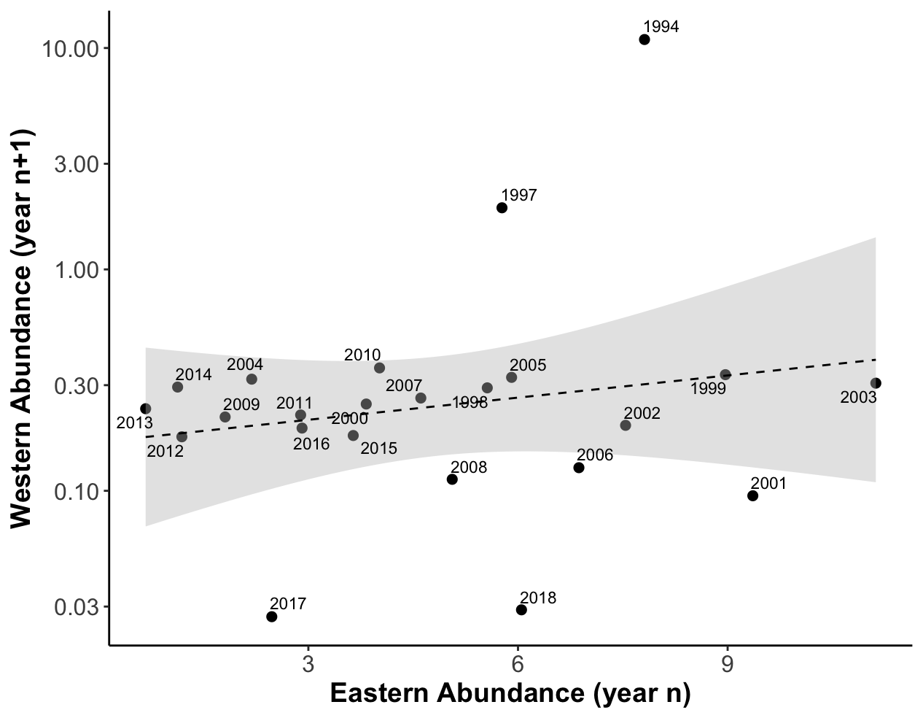
Figure S5– When two years (1995 and 1996 in the east, 1996 and 1997 in the west) are omitted from time series, the correlation between eastern and western overwintering numbers using a one year time lag is no longer significant (R² = 0.06, p = 0.275).

